Input/output Devices

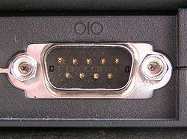Port connectivity

Ports are generally of two types:

* Serial ports

Serial ports are an interface which transfer only one bit at a time either as input/output. They are simple and easy to configure which is why they are used as a control console in diagnostics. Furthermore, they are widespread